Collin Gamble
PRO390 – Capstone Project
Week 7: Security Remediation Validation & Defense Testing
Degree: Information Systems & Cybersecurity
Date: February 21st, 2026

1. Introduction
The purpose of Week 7 was to validate the effectiveness of all security mitigations implemented during Week 6. After intentionally introducing and exploiting vulnerabilities in Weeks 4 and 5, remediation strategies were applied to address injection flaws, stored XSS, account enumeration, insecure session configuration, and related security weaknesses.
This phase focused on structured retesting of previously successful attack payloads to confirm that:
- Exploits no longer succeed
- Defensive controls operate as expected
- Security posture has measurably improved
- Layered security mechanisms prevent chained attacks
All validation testing was performed locally on localhost using Postman and standard web browsers. No production systems or real user data were involved.
Screenshots referenced throughout this document correspond to evidence captured during mitigation validation testing.

2. Defense Validation Scenario 1: NoSQL Injection Prevention
Vulnerability Previously Exploited
NoSQL Injection – Authentication Bypass
OWASP Top 10 (2021): A03 – Injection
Tools Used
Postman

Previous Behavior (Week 5)
The following payload successfully bypassed authentication:
{
"username": { "$ne": null },
"password": { "$ne": null }
}
This resulted in:
- Successful authentication
- Issuance of a valid session cookie
- Access to protected routes

Remediation Implemented (Week 6)
- Strict string handling of authentication inputs
- Removal of direct operator injection vectors
- Implementation of express-mongo-sanitize
- CSRF protection using csurf middleware
- Generic login error messaging

Retesting Steps
- Sent a POST request to /login without a CSRF token.
- Sent a POST request with a fake CSRF token.
- Sent a POST request with a valid CSRF token and the original injection payload.
- Attempted to access /dashboard after login attempt.

Result
- Requests without a valid CSRF token returned:
403 – CSRF token validation failed.
- Requests with a fake token returned:
403 – CSRF token validation failed.
- Requests with a valid CSRF token and injection payload returned:
Wrong username or password.
- No session cookie was issued.
- Protected routes remained inaccessible.
Authentication bypass was no longer possible.

Evidence Collected
- Postman No token error.jpg
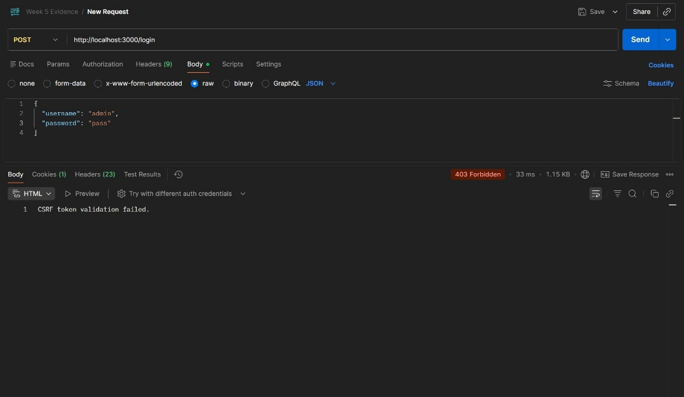
- Postman With Fake Token error.jpg
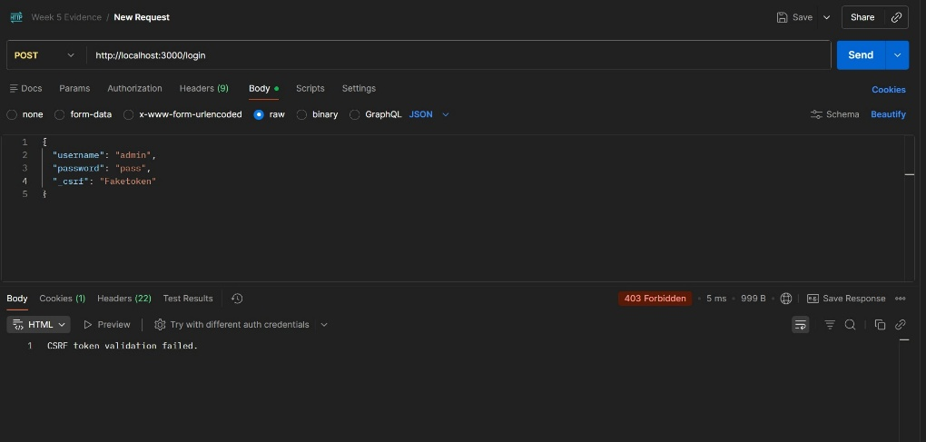
- Postman CSRF token validation failed.jpg
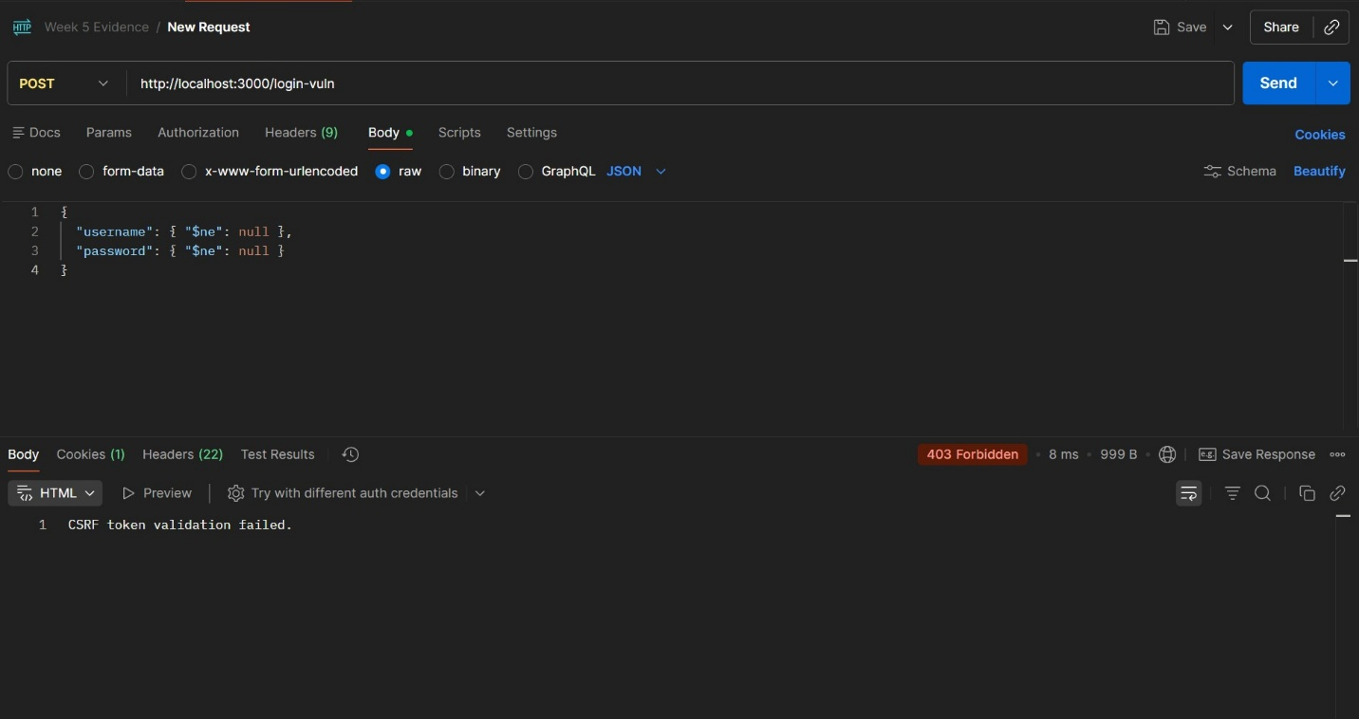
- Postman With Real token working.jpg
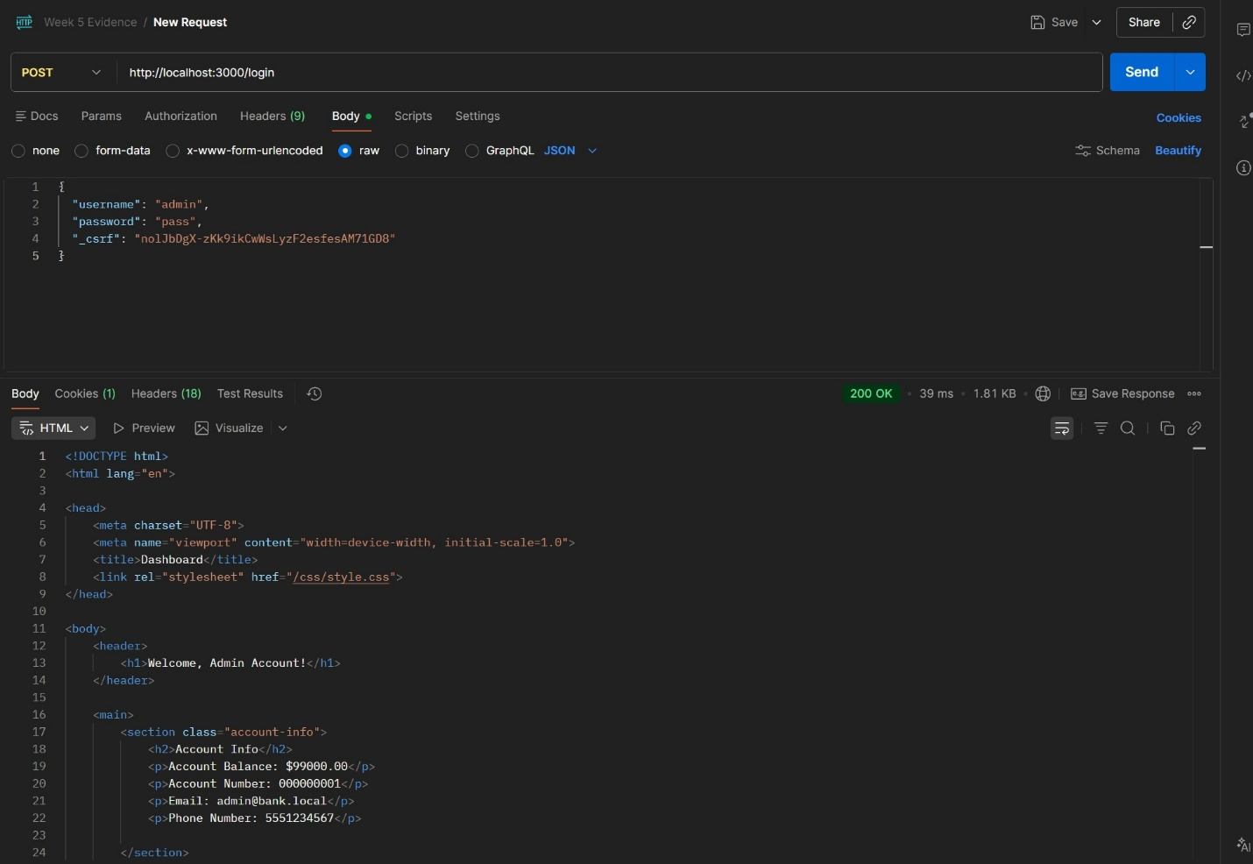

- Postman Get request showing token.jpg
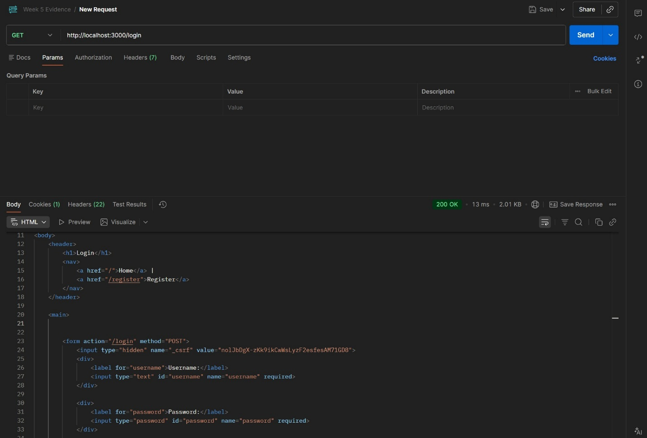

These screenshots demonstrate layered defense blocking injection attempts at multiple levels.

3. Defense Validation Scenario 2: Stored Cross-Site Scripting (XSS) Mitigation
Vulnerability Previously Exploited
Stored XSS – Persistent Client-Side Injection
OWASP Top 10 (2021): A03 – Injection
Tool Used
Web Browser

Previous Behavior (Week 5)
The following payload executed when viewing the transactions page:
<img src=x onerror="alert('Stored XSS')">
JavaScript executed automatically, confirming persistent stored XSS.

Remediation Implemented (Week 6)
- Restored default EJS escaped output (<%= %>)
- Removed raw HTML rendering
- Verified safe template rendering across all views
- Implemented Content Security Policy via Helmet

Retesting Steps
- Submitted the original XSS payload via the transfer memo field.
- Completed the transfer.
- Navigated to the transactions page.

Result
- The payload rendered as plain text.
- No JavaScript executed.
- No alert box appeared.
- Script execution was successfully blocked.
Stored XSS was fully mitigated.

Evidence Collected
- Showed memo XSS script on transfer funds page.jpg
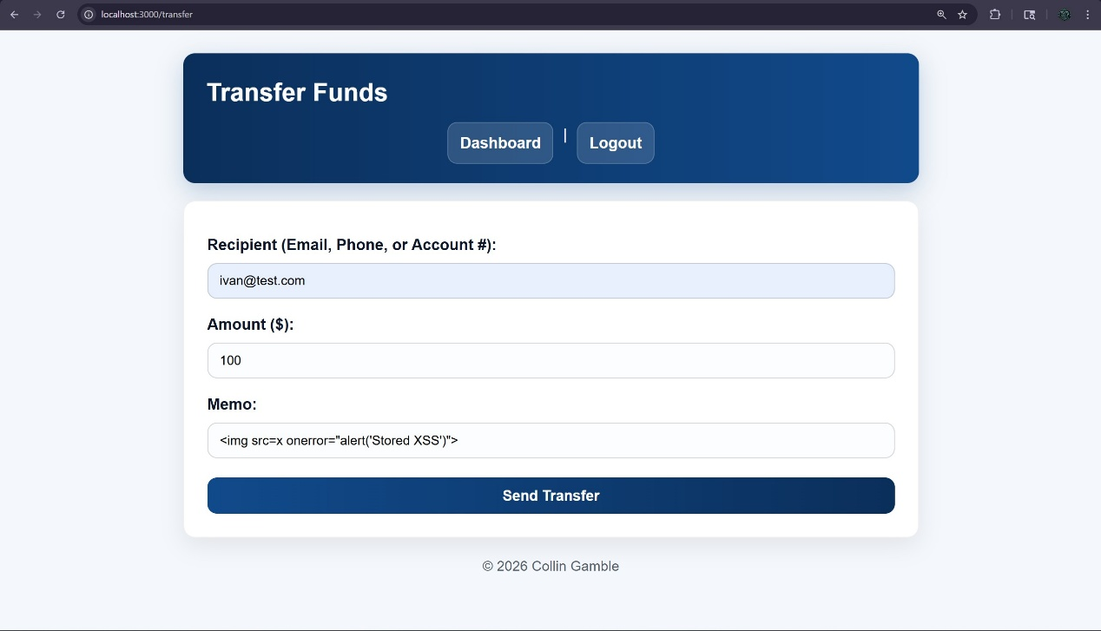
- XSS script no alert popped up.jpg
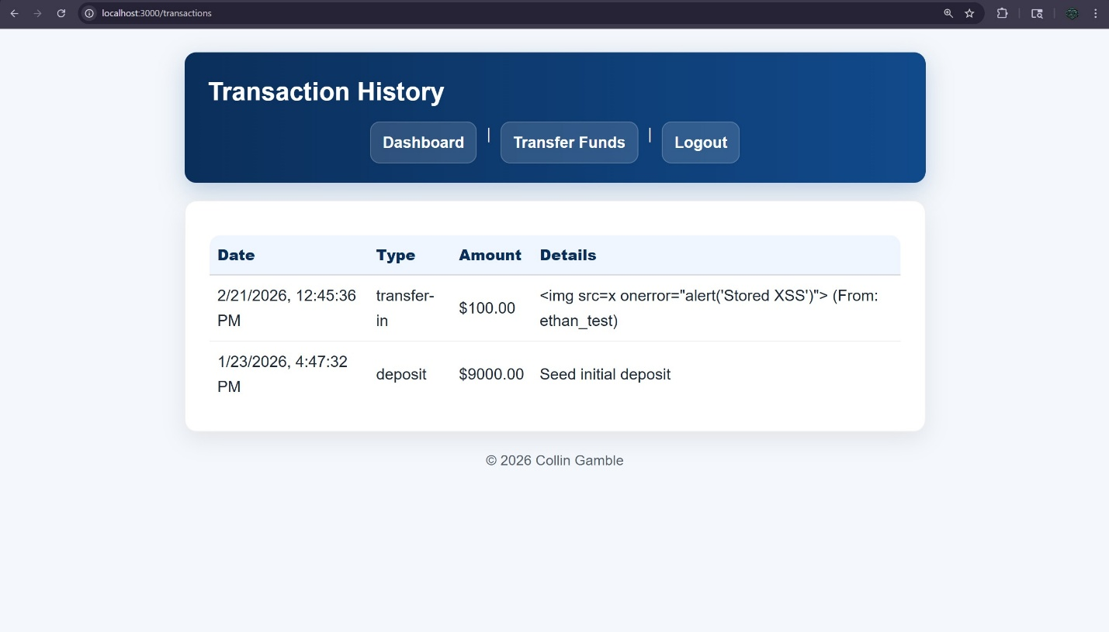
These screenshots confirm that the malicious input was rendered safely and did not execute.

4. Defense Validation Scenario 3: Account Enumeration Prevention
Vulnerability Previously Exploited
Account Enumeration via Verbose Error Messages
OWASP Top 10 (2021): A07 – Identification & Authentication Failures
Tool Used
Web Browser

Previous Behavior (Week 5)
Distinct responses were returned for:
- Nonexistent username
- Valid username + incorrect password
- Incorrect email during password reset
This allowed confirmation of valid account existence.

Remediation Implemented (Week 6)
- Standardized login error message:
Wrong username or password.
- Standardized forgot-password response:
If the account exists, you will be able to reset your password.
- Removed all verbose internal state messaging.

Retesting Steps
- Attempted login with nonexistent username.
- Attempted login with valid username and incorrect password.
- Attempted password reset with mismatched username/email combinations.

Result
All authentication failures returned consistent generic responses.
No distinction was observable between:
- Nonexistent usernames
- Incorrect passwords
- Email mismatch scenarios
Enumeration was successfully mitigated.
Evidence Collected
- Login page wrong username or password error message.jpg
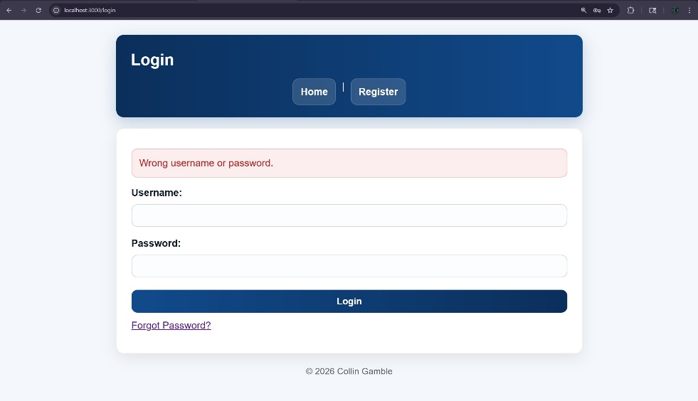
- Forgot Password error message.jpg
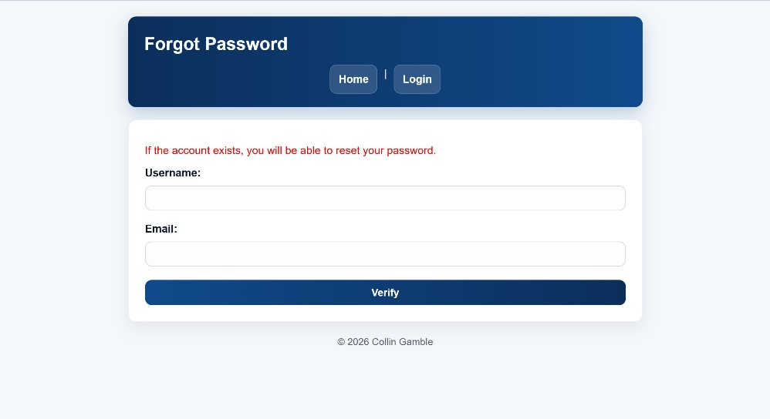
These screenshots confirm consistent error messaging across scenarios.

5. Defense Validation Scenario 4: Session Security & Cookie Hardening
Vulnerability Previously Exploited
Insecure Session Cookie Configuration
OWASP Top 10 (2021): A05 – Security Misconfiguration

Previous Behavior (Week 5)
- HttpOnly flag disabled
- Session cookie accessible via document.cookie
- Combined with XSS for potential hijacking

Remediation Implemented (Week 6)
- Enabled HttpOnly flag
- Enabled SameSite policy
- Hardened session configuration
- Disabled lab-mode insecure cookie behavior

Retesting Steps
- Inspected cookies in browser Developer Tools.
- Attempted JavaScript access to session cookie.
- Verified cookie attributes.

Result
- Session cookie marked HttpOnly.
- Session cookie protected from client-side access.
- No exposure via JavaScript.
- Chained attack no longer possible.

Evidence Collected
- Site cookies safe.jpg
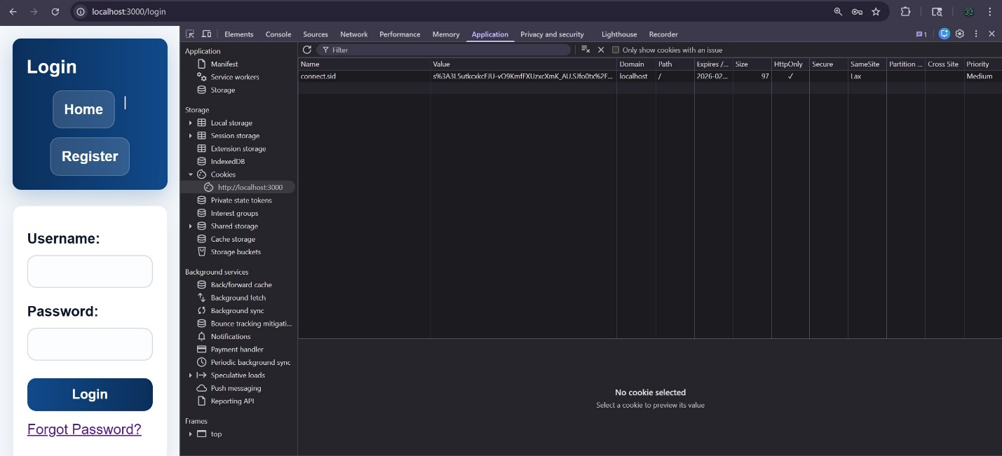
These screenshots confirm proper secure cookie configuration.

6. Defense Validation Scenario 5: Rate Limiting Protection
Vulnerability Previously Exploited
Brute-Force Authentication Attempts

Remediation Implemented
- Implemented express-rate-limit on authentication routes.
- Limited repeated login attempts within defined window.

Retesting Steps
- Sent repeated login attempts exceeding limit threshold.
- Observed server response.

Result
Server returned:
429 – Too Many Requests
Further login attempts were temporarily blocked.
Brute-force mitigation functioning correctly.

Evidence Collected
- Error 429 too many requests.jpg
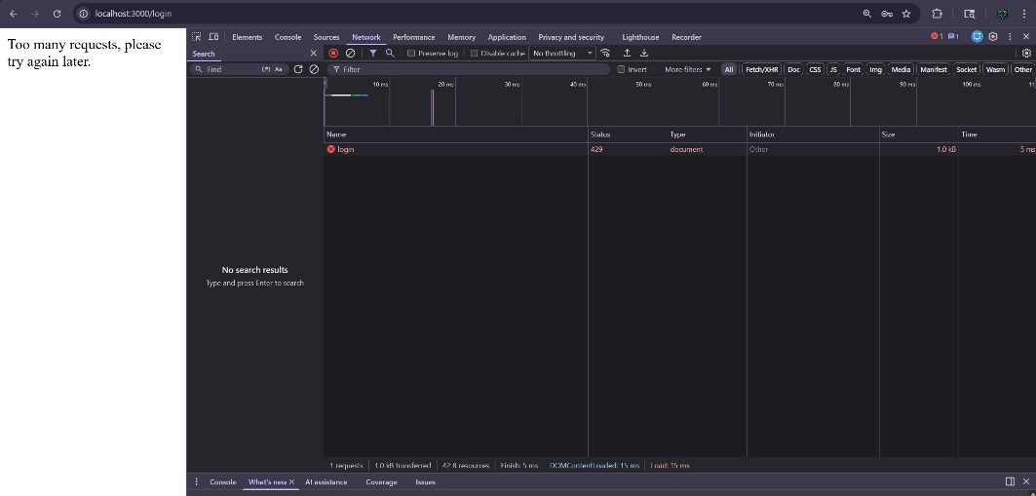
- Rate limiting error.jpg
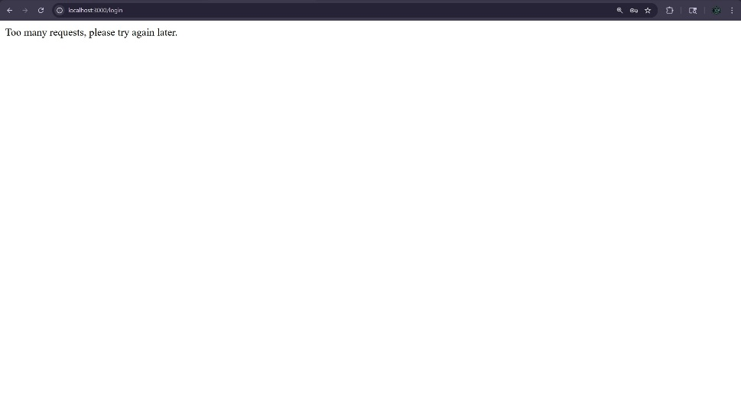
7. Summary of Security Improvements
The mitigation validation phase demonstrates measurable improvement in application security posture:
Vulnerability | Week 5 Result | Week 7 Result
NoSQL Injection | Authentication bypass | Blocked
Stored XSS | JavaScript execution | Safely rendered
Account Enumeration | Username discovery | Generic response
Insecure Session | Cookie accessible | HttpOnly enforced
Brute Force | Unlimited attempts | Rate limited
All previously exploitable vulnerabilities were successfully mitigated. Retesting confirms that layered security controls (input validation, output encoding, CSRF protection, session hardening, rate limiting, and secure middleware configuration) are functioning as intended.
The application now demonstrates a significantly improved security posture consistent with modern web security best practices.

AI Assistance Disclosure
Portions of this document, including organization, formatting, and refinement of written explanations, were drafted and edited with the assistance of AI (ChatGPT). All remediation implementation, retesting, validation, screenshot collection, and analysis were performed by the student.

